---------------------------------------------------------------------

-- LAB 03

--

-- Exercise 2

---------------------------------------------------------------------

USE TSQL;

GO

---------------------------------------------------------------------

-- Task 1

--

1-- Write a SELECT statement against the Sales.Customers table showing only the country column.

--

2-- Execute the written statement and compare the results that you got with the desired results shown in the file Lab Exercise 2 - Task 1 Result.txt.

---------------------------------------------------------------------

---------------------------------------------------------------------

-- Detyre 1

--

1-- Selektoni vetem kolonen country nga tabela Sales.Customers.

--

2-- Ekzekutoni veprimet e mesiperme dhe krahasoni rezultatet qe ju moret me rezultatet e deshiruara ne dokumentin Lab Exercise 2 - Task 1 Result.txt.

---------------------------------------------------------------------

USE TSQL

GO

Select sc.country

From Sales.Customers sc

ose

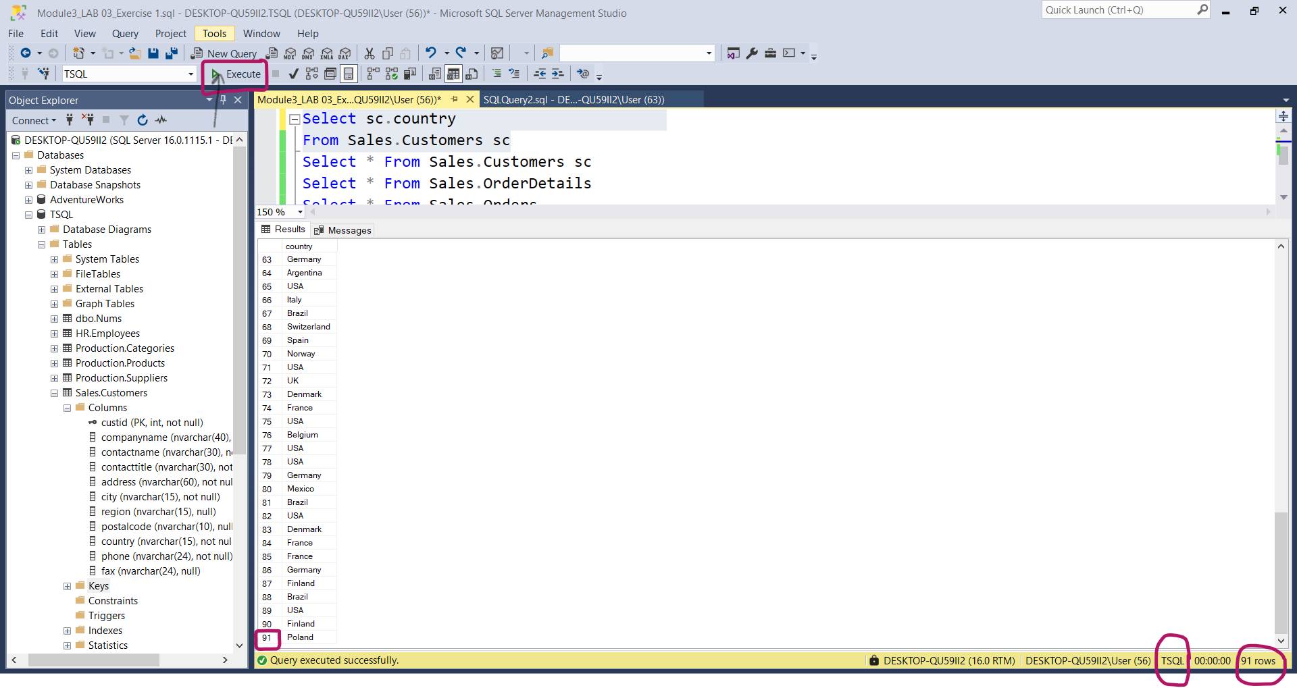

2-

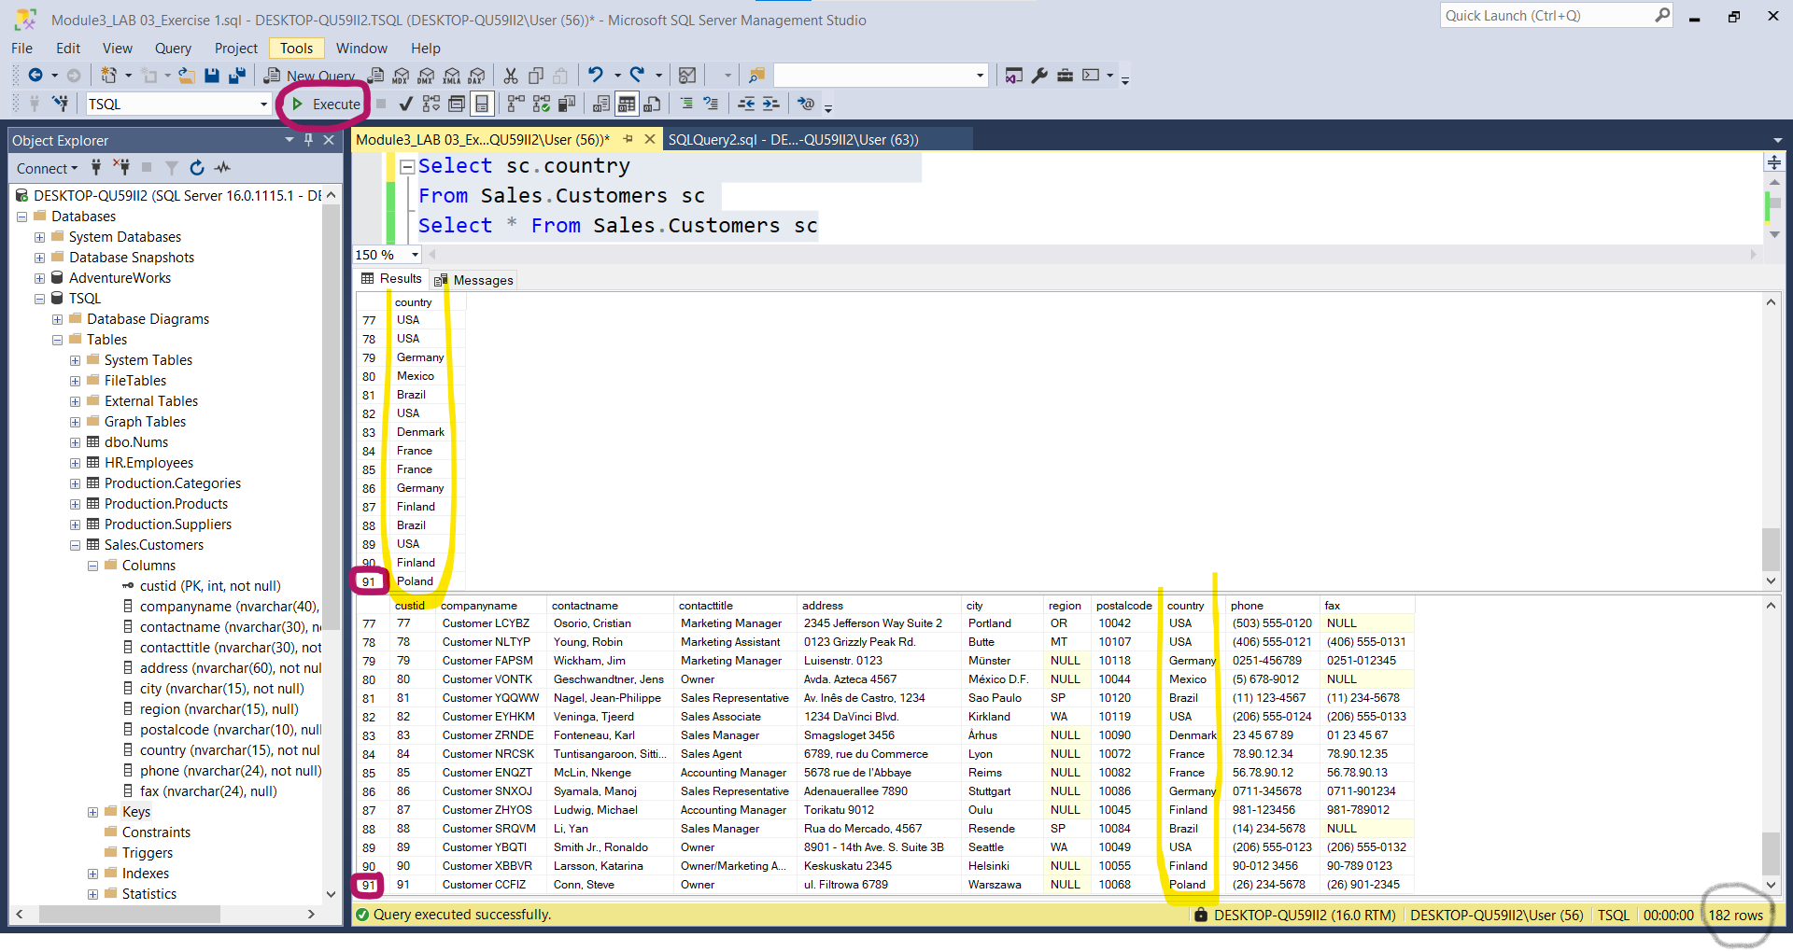

---------------------------------------------------------------------

-- Task 2

--

1-- Copy the SELECT statement in Task 1 and modify it to return only distinct values.

--

2-- Execute the written statement and compare the results that you got with the desired results shown in file Lab Exercise 2 - Task 2 Result.txt.

-- How many rows did the query in Task 1 return?

-- How many rows did the query in Task 2 return?

---------------------------------------------------------------------

---------------------------------------------------------------------

-- Detyre 2

--

1-- Kopjoni veprimet ne Detyre 1 and modifikojeni ato per te kthyer vetem vlerat unike.

--

2-- Ekzekutoni veprimet e mesiperme dhe krahasoni rezultatet qe ju moret me rezultatet e deshiruara ne dokumentin Lab Exercise 2 - Task 2 Result.txt.

2.1-- Sa rrjeshta kthej query ne Detyren 1 ?

2.2-- Sa rrjeshta kthej query ne Detyren 2 ?

---------------------------------------------------------------------

1--

Select Distinct sc.country From Sales.Customers sc

2—After I clicked ‘Execute’ button

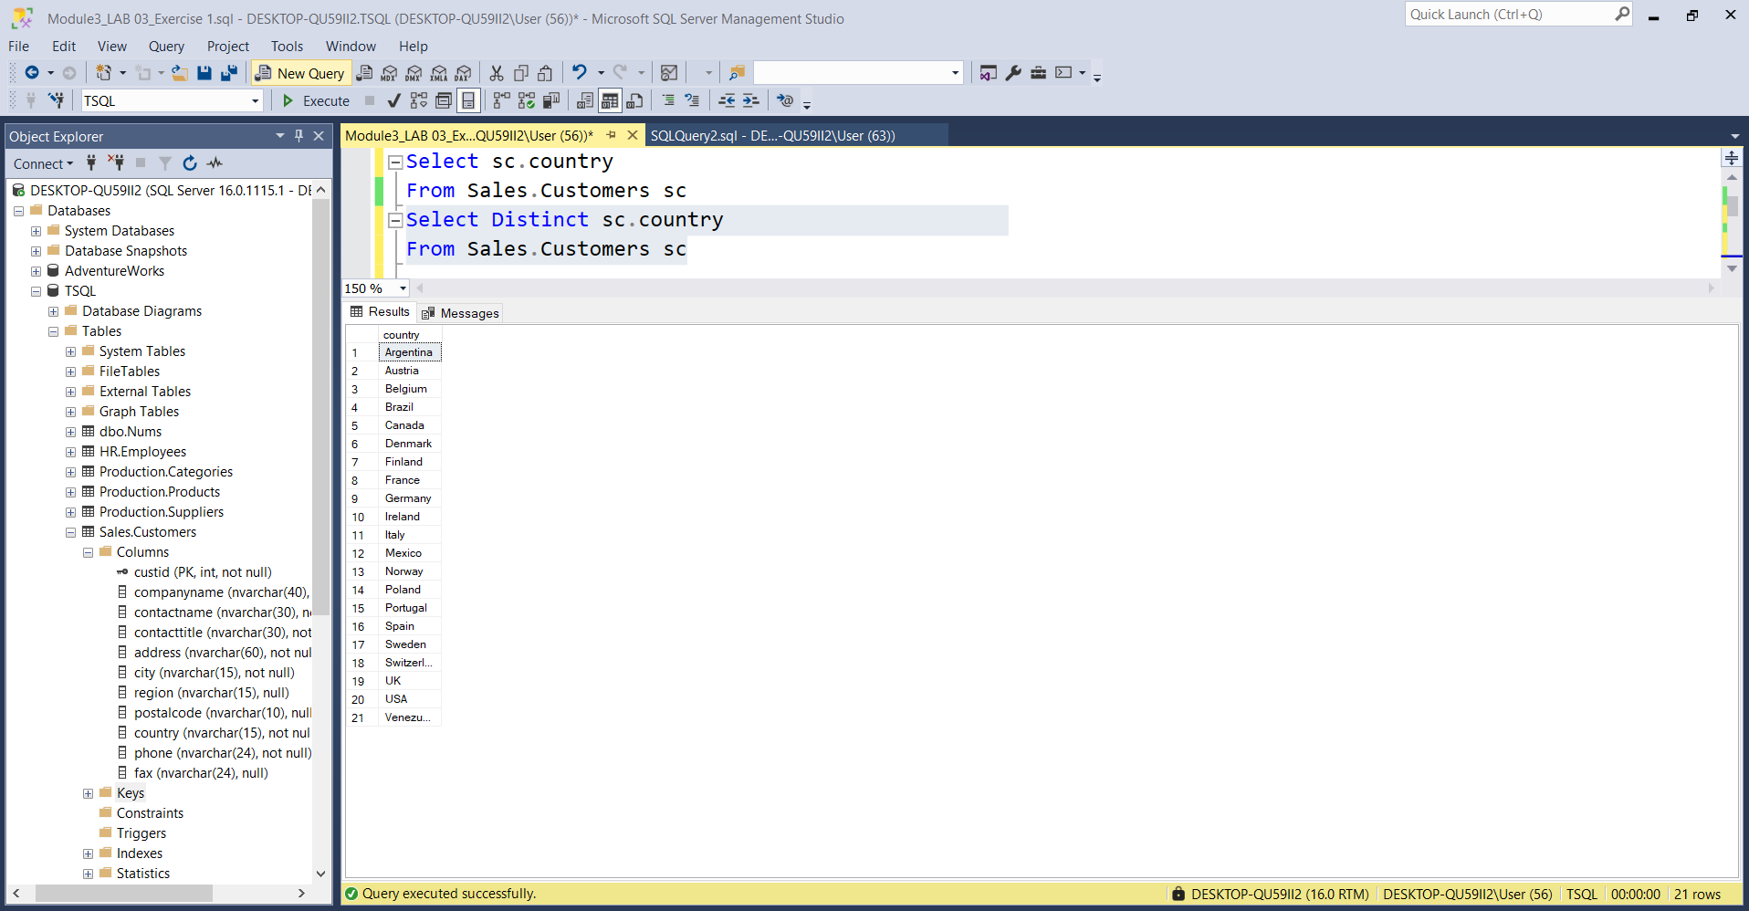

2.1—21 rreshta

2.2—21 rreshta

---------------------------------------------------------------------

3-- Under which circumstances do the following queries against the Sales.Customers table return the same result?

--

4-- Is the DISTINCT clause being applied to all columns specified in the query or just the first column?

---------------------------------------------------------------------

SELECT city, region

FROM Sales.Customers;

SELECT DISTINCT city, region

FROM Sales.Customers;

---------------------------------------------------------------------

3-- Ne cilat situata query e meposhtme japin te njejtin rezultat ?

--

4-- A eshte zbatuar DISTINCT ne te gjitha kolonat e specifikuara nga query apo vetem ne kolonen e pare?

---------------------------------------------------------------------

SELECT city, region

FROM Sales.Customers;

SELECT DISTINCT city, region

FROM Sales.Customers;

3--Në asnjë situate nuk japin të njëjtin rezultat

4—Distinct duket se eshte zbatuar per te gjitha rreshtat.Konkretisht:

